

**UNIVERSITY OF CALIFORNIA,**

**IRVINE**

**CompSci 271: Introduction to Artificial Intelligence**

**(Reversi) Othello**

**Project report**

**Professor: Kalev Kask**

**Mutian Xu 16083274**

**Qiqi Pan 47287934**

**Jing Liao 65763768**

1. **Instruction**

Othello is a strategic 8×8 board game for two players. It is sometimes named Reversi. One plays discs in white color and the other player plays black discs. Each disc is double-sided with one side colored white and the other side colored black (our game uses W and B to denote, respectively). The game board has 64 identical squares. Modern times this game is often played on a computer instead of an actual game board. In the modern version of Othello, first four discs played are default in setting rather than played by players. At the opening of the game, two white discs and two black discs are placed at the center of the game board in the pattern as shown in Figure 1-1 (Al Sweigart, 2015). In our game, computer (AI player) plays first and it uses white

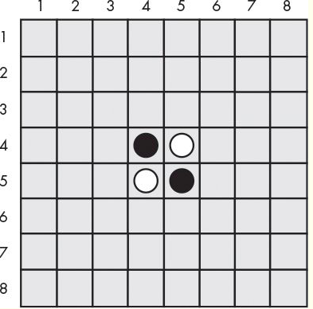

*Figure 1-1: the Opening of the Othello Game (Al Sweigart, 2015)*

discs. Human player (Player2 ) moves after the AI player and uses black discs. Opposing player can only make legal moves. We define legal moves as placing discs only on some certain squares. AI player’s white discs can only be placed on squares if the square satisfies that there exists at least one straight (horizontal, vertical, or diagonal) occupied line between the new piece and another white piece, with one or more contiguous black pieces between them (Al Sweigart, 2015). For example, in Figure 1-1, AI player must place white discs on (3, 4), (4, 3), (5, 6), or (6, 5). All other moves are considered as illegal moves such that cannot be made. Players can also flip the opponent’s discs to their own color as long as flipped discs are between the player’s new disc and an existing disc of that color. The game ends when there is not legal move can be made by both players or all squares are being filled up. The winner is the player with more discs in its color on the board.

1. **Algorithms**

There are many algorithms can be applied in Othello, such as Stochastic Search, MinMax, AlphaBeta purning, AlphaBeta(with history), Dynamic Programming, Monte Carlo, Reversi Learning etc. We used MinMax and AlphaBeta purning to solve the problem. AlphaBeta purning performed better than MinMax in Adversarial search.

**2.1 Evaluation function**

The valuation based on the chessboard and mobility is mainly used. The chess table is actually on the board. The weight table of different positions is set based on the game strategy [Game strategy of Othello]

**C-squares and X-squares**：C-squares are the squares at a2、a7、b1、b8、g1、g8、h2 and h7，X-squares are the squares at b2、b7、g2 and g7, These squares should only be occupied with care.

**Center** : The center of a position is the set of interior discs.

**Control of the center** : Strategy which consists of trying to have as many of your discs as possible in the center of the position and as few as possible along the frontier for the maximum possible mobility.

**Corner** : The corners are the squares at a1, a8, h1, and h8. They are often very good squares to occupy.

Based on the strategy above, we set our chess board weight as

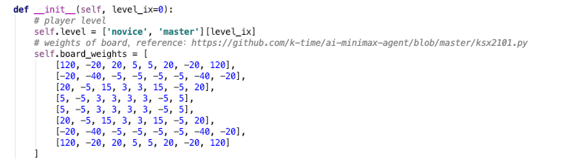

Then the evaluation based on the chess board weight is:

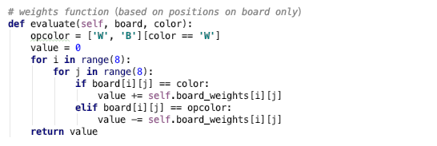

* 1. **Minimax Algorithm**

The minimax algorithm (Russell and Norvig, 2010) computes the minimax decision from the current state. It uses a simple recursive computation of the minimax values of each successor state, directly implementing the defining equations. The recursion proceeds all the way down to the leaves of the tree, and then the minimax values are backed up through the tree as the recursion unwinds. An example is shown below(Bai, 2007):

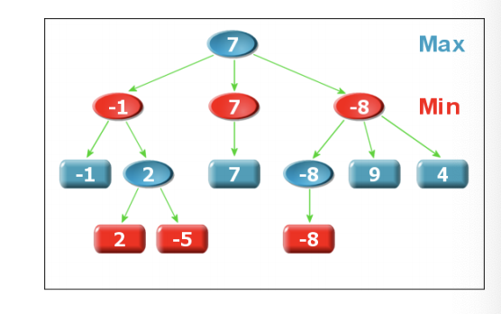

*Figure 2-2-1: example of Minimax Algorithm*

1. My player is the Max’s node，the competitor is the Min’s node;
2. The leaf node calls the evaluation function and propagates its value up;
3. Max node is assigned the maximum value of all its children;
4. The Min node is assigned the minimum value of all its children;
5. The root node selects the action corresponding to the node with the largest value among its child nodes as the best action.

The minimax algorithm (Russell and Norvig, 2010) performs a complete depth-first exploration of the game tree. If the maximum depth of the tree is m and there are b legal moves at each point, then the time complexity of the minimax algorithm is O(bm). The space complexity is O(bm.) for an algorithm that generates all actions at once, or O(m) for an algorithm that generates actions one at a time. For real games, of course, the time cost is totally impractical, but this algorithm serves as the basis for the mathematical analysis of games and for more practical algorithms.

The Pseudocode for Minimax algorithm is shown as following:

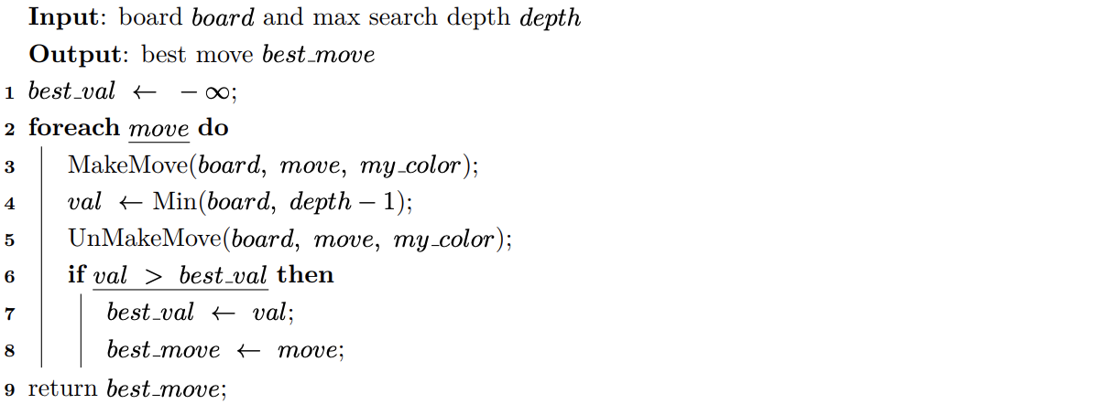

*Figure 2-2-2: Algorithm1 Minmax*

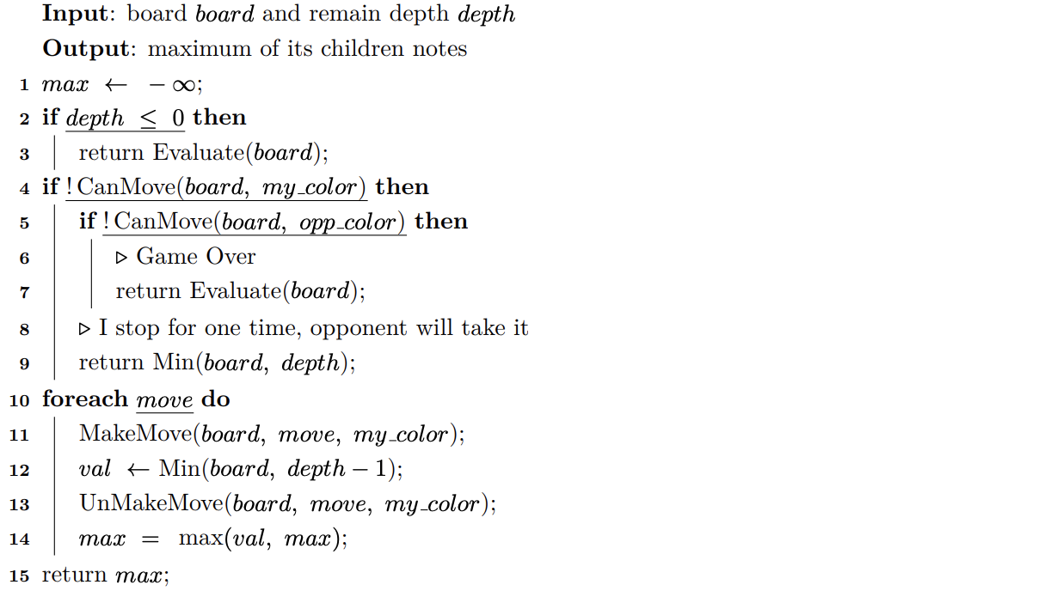

*Figure 2-2-3: Algorithm2 Max*

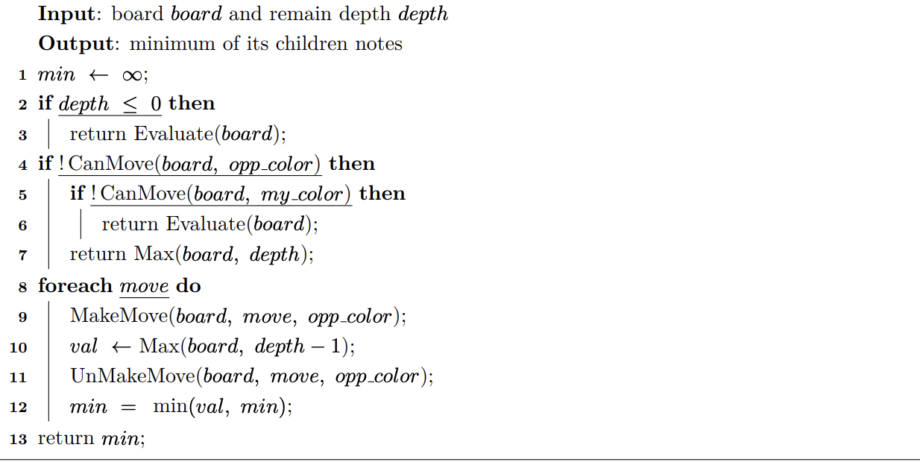

*Figure 2-2-4: Algorithms 3 Min*

Minimax algorithm in our game is as following:

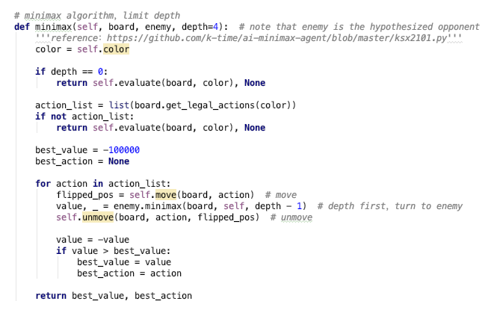

*Figure 2-2-5: Minimax Algorithm in Our Game*

However, one potential problem with minimax search is that the number of game states it has to examine is exponential in the depth of the tree. Unfortunately, we can't eliminate the exponent, but it turns out we can effectively cut it in half. The trick is that it is possible to compute the correct minimax decision without looking at every node in the game tree. That is, we can eliminate large parts of the tree from consideration. The particular technique we examine is called alpha—beta pruning (Russell and Norvig, 2010). When applied to a standard minimax tree, it returns the same move as minimax would, but prunes away branches that cannot possibly influence the final decision.

**2.3 Alpha-Beta purning**

Pruning in general is an idea to eliminate nodes without examining them, which makes no difference in the final decision (Russell and Norvig, 2010). Alpha-Beta Pruning also prunes trivial nodes away that do not have effect on our final decision. This make the search much more effective. To be more specific, alpha-beta pruning can solve a tree that is roughly twice as deep as minimax using same amount of time (Russell and Norvig, 2010). We can see that time per node is reduced in Alpha-beta pruning in Figure 2-2-1(Bai, 2007). Smaller ray value means better effect of pruning. There is evidence for reduced ray value and shorter time per node

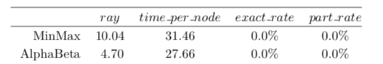

*Figure2-3-1: Comparison between MinMax and AlphaBeta (Bai, 2007)*

in the study.

Following is an example of Alpha-Beta pruning.

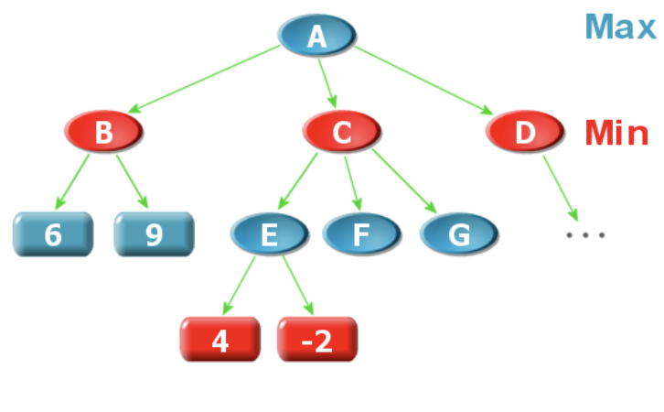

*Figure2-3-2: Example of Alpha-Beta Pruning (Bai, 2007)*

In Figure 2-2-2 (Bai 2007), suppose A is the Max node, it will be assigned to B、C、D’s max value. In order to know the value of A, we first need to know the value of B. For this we search for the child of B and assign B the value is 6, because B is the Min node. Then we start to determine the value of C. We first search for the values ​​of the two children of E and E respectively. For 4 and -2 , E is a Max node, so the value of E is 4 . Because C is a Min node, we know that the value of C is set to less than or equal to 4, so C will not be selected by A because A is a Max node, and now there is already a child Node B with a large value than 4. So there is no need to search for F and G. That is, pruning has taken place.

The algorithm implements two values ​​for each node: α and β, which respectively represent the lower and upper limits allowed by the node's evaluation.

An interval, called the α-β window, is defined as β − α − 1 . Initially, the root node is α = −∞,β = ∞, the α, β values ​​of other nodes are inherited from its parent in the depth-first search process. For the above example, when after searching for B, we know that A's final estimate is definitely not less than the value of B (because A is a Max node), and the lower limit is the alpha value of A, α = 6. Continue the depth-first search. When E is searched, the upper limit of C is determined (C is the Min Point), at this time, the β value of C is 4, and it is noted that the α of C is also 6 (this is inherited from A), as discussed in the previous discussion, C is pruned, in fact, when β ≤ α, pruning occurs.

We see that both α and β are updated during the depth-first search. For the Max node, if the child returns When the value is greater than α, α is updated to the return value. For the Min node, the process is just the opposite, β is updated to a subsection smaller than it. The return value of the point. Theαvalue of the M ax node does not decrease, and theβvalue of the M in node does not increase. When β ≤ α of a node, pruning will occur. The puncture of the Max node is called β pruning, and the Min node is called α pruning. According to the return value of the child node

With the relationship between α and β, the child nodes can be divided into three categories (taking the Max process as an example, and S representing the corresponding Max node, S’ represents a child node):

1. Very poor node, V (S′) ≤ α， S ′certainly would not be chosen, need to continue searching for the next child node；
2. Very nice node V (S′) ≥ β， β was pruned；
3. Main step node α < V (S′) < β，no pruning but it is possibly, search keep going.

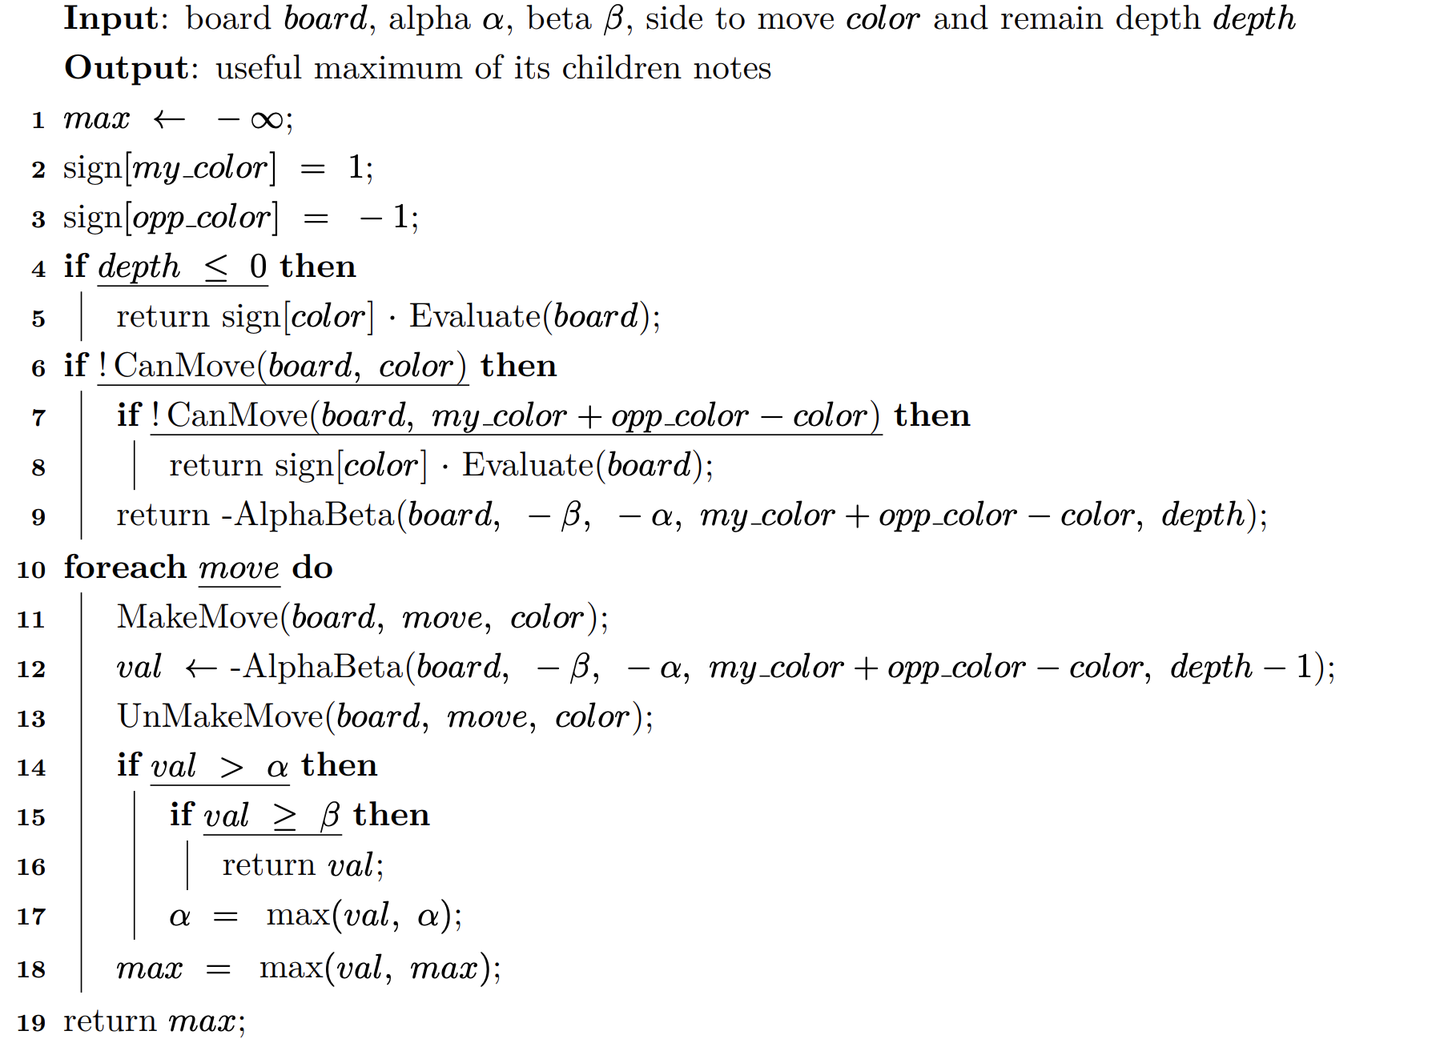

*Figure 2-3-3. Pseudocode alpha-beta purning searching*

Alpha-beta pruning in our game is as following:

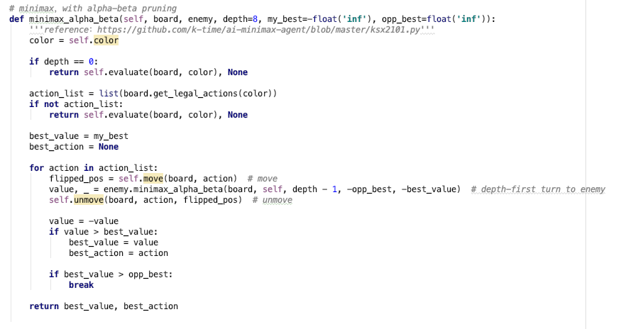

*Figure 2-3-4: Alpha-beta Pruning in our game*

1. **Tests**

We used Python to realize our algorithms.

Machine: Alienware (13-inch, 2016)

Processor: Intel Core i7

RAM: 16G

**Test 1:** Control for depth of AI. Depth of hypothesized enemy varies (Competition between two AI players). Test result as followed:

|  |  |  |  |  |
| --- | --- | --- | --- | --- |
| Order | Depth of Hypo. Enemy of player B | Depth of Hypo. Enemy of player W | Result (Winner) | Running Time |
| 1 | 1 | 2 | Draw | 0.0219 |
| 2 | 1 | 3 | W | 0.1838 |
| 3 | 2 | 2 | Draw | 0.0375 |
| 4 | 2 | 3 | Draw | 0.2027 |
| 5 | 2 | 4 | Draw | 1.9588 |
| 6 | 3 | 1 | B | 0.1875 |
| 7 | 3 | 2 | Draw | 0.1328 |
| 8 | 3 | 4 | W | 1.4406 |
| 9 | 4 | 2 | Draw | 1.6405 |
| 10 | 4 | 3 | Draw | 1.1583 |
| 11 | 4 | 4 | W | 2.0509 |

*Table 1*

**Data in table 1 is obtained from the terminal of our code, which is shown in Appendix.**

**Test 2:**

Human player vs. AI player. We assume human player always place first disc on e3 and the second disc on e2. We only change the depth of hypothesized enemy of AI from 2 to 5. Test result as followed:

Hypothesized enemy of AI = 2:

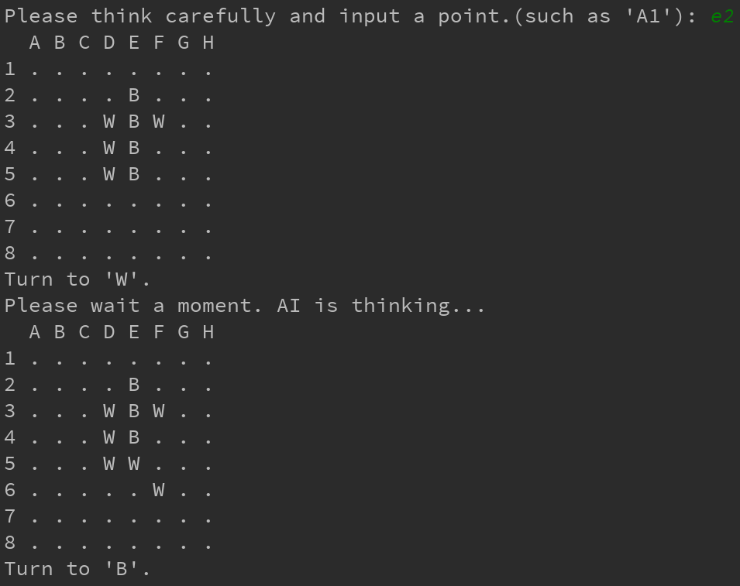

Hypothesized enemy of AI = 5:

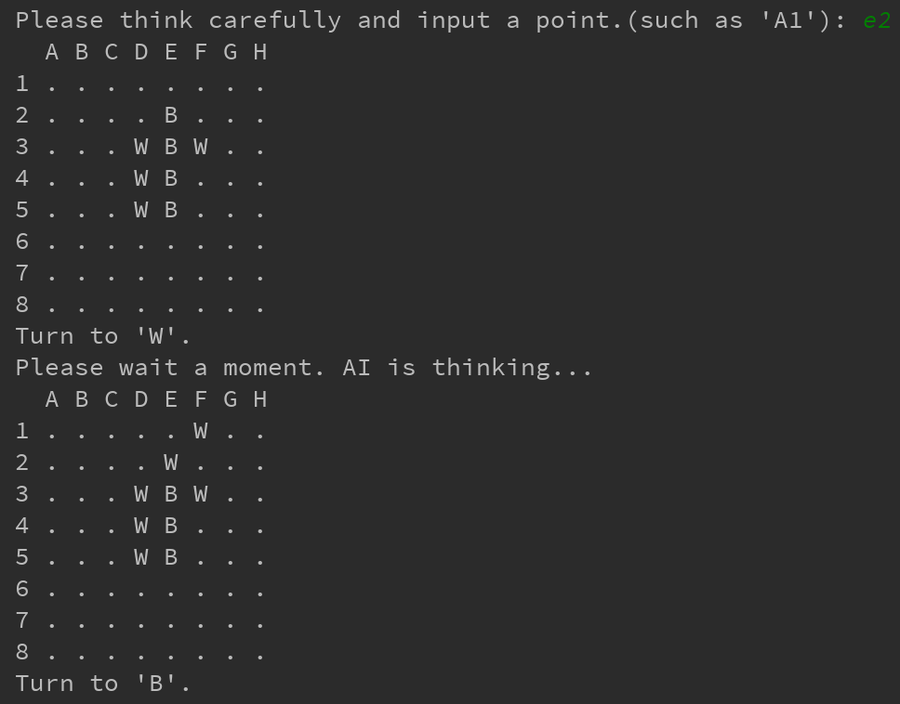

To check if results are correct, you can read the ReadMe.txt and follow the instructions to achieve it.

**4. Conclusion**

**From test 1, we conclude the following results:**

Result about **probability of winning**:

* When one of AI’s hypothesized enemy depth = 1 and the other AI’s hypothesized enemy depth $≥$ 3, the latter one wins. This shows that the probability of winning increases as depth increases. (See comparison between 2 and 6 in table 1)
* When depth of hypothesized enemy is close to each other and one of them is big enough (greater than 1), it is more likely to end with draw. (See comparison among 1, 3, 4, 5, 7, 9, 10 in table 1)

Result about **running time**:

* When one of the depth of two hypothesized enemy is big enough ( $depth ≥$ 4), the running time increases significantly.

**From test 2, we conclude the following results:**

* When depth of AI’s hypothesized enemy = 5, discs will be placed on squares with higher weights, which leads to higher probability of winning.

**In general, our results tell us that as depth increases, the searching scale of our algorithm increases, which results in increased running time and probability of winning.**

**Acknowledgement**:

Thanks to Dr. Kalev Kask for the instruction of the course, CS271: Introduction to Artificial Intelligence, in Fall 2018;

Thanks to all the people who give our team suggestions for the project.

**Reference:**

*Russell, S. J., Norvig, P., & Davis, E. (2010).* *Artificial intelligence: A modern approach. Upper Saddle River: Prentice Hall.*

*Sweigart, A. (2015). CH.15 THE REVERSEGAM GAME Invent your own computer games with Python. Lexington, KY: Al Sweigart.*

*Game strategy of Othello.*

Retrieved from http://radagast.se/othello/Help/strategy.html

*Algorithms in Othello .*

Retrieved from <https://aijunbai.github.io/publications/USTC07-Bai.pdf>

*AI-Minimax-Agent*

Retrieved from https://github.com/k-time/ai-minimax-agent/blob/master/ksx2101.py

*Botzone zone.*

Retrievedfrom:http://www.personal.umd.umich.edu/~leortiz/teaching/6.034f/Fall06/csp/csp_notes.pdf

*Othello-evaluation-function.*

Retrieved from https://stackoverflow.com/questions/12334216/othello-evaluation-function

**Appendix:**

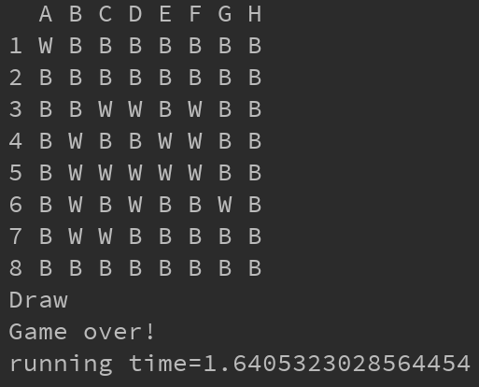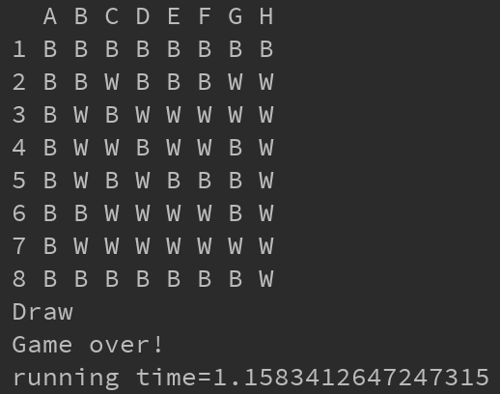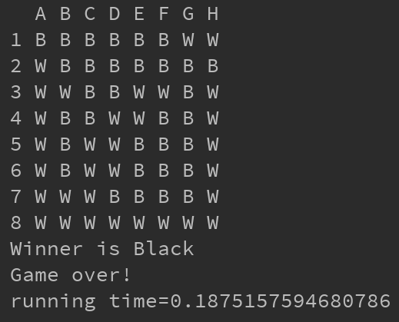

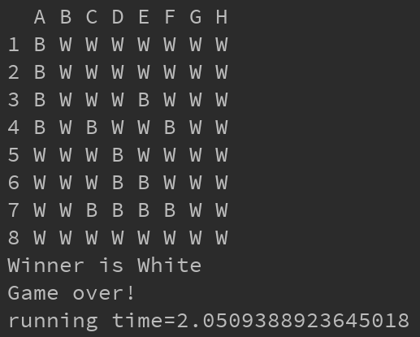

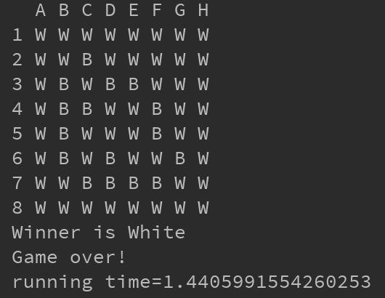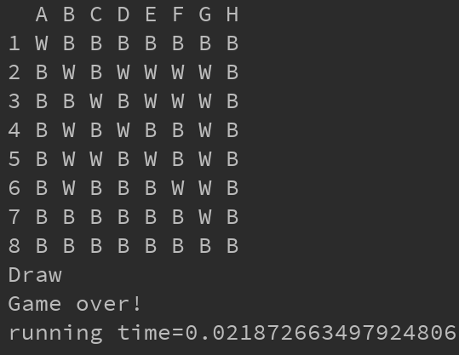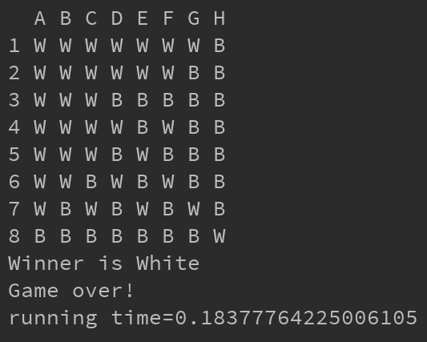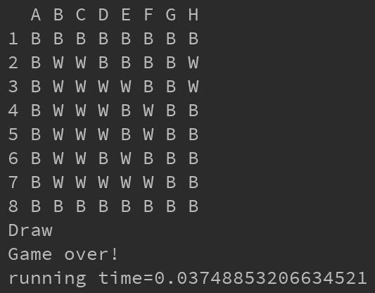

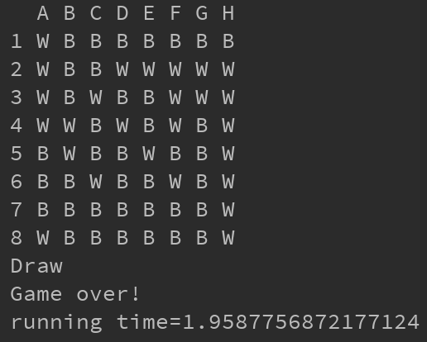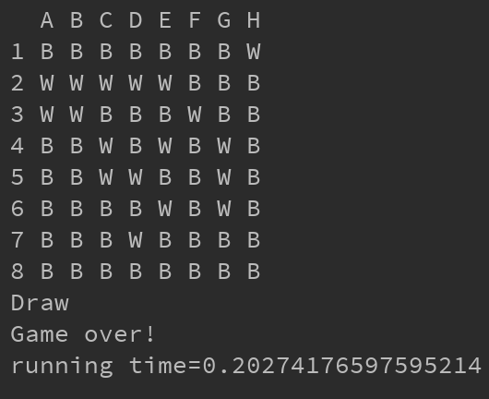

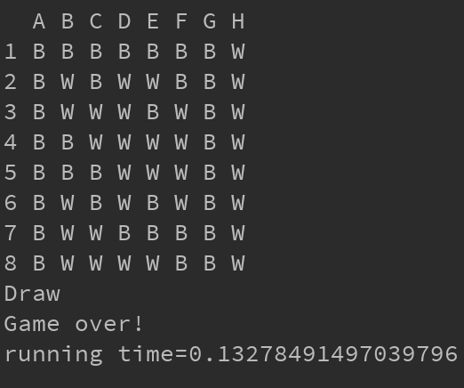

**Optional:**

Easy (one star)

Probability of winning = 100%

Average number of back discs at winning: 46.4

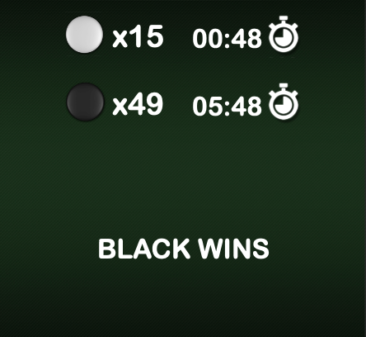

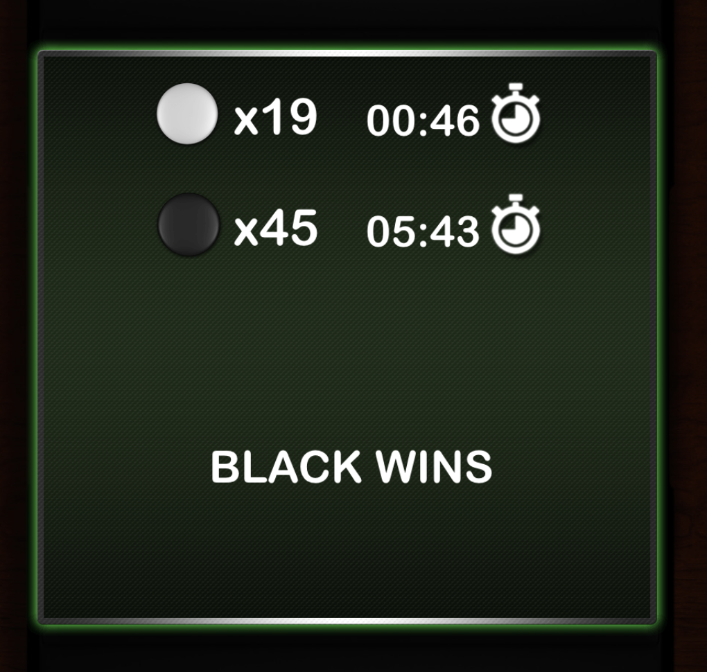

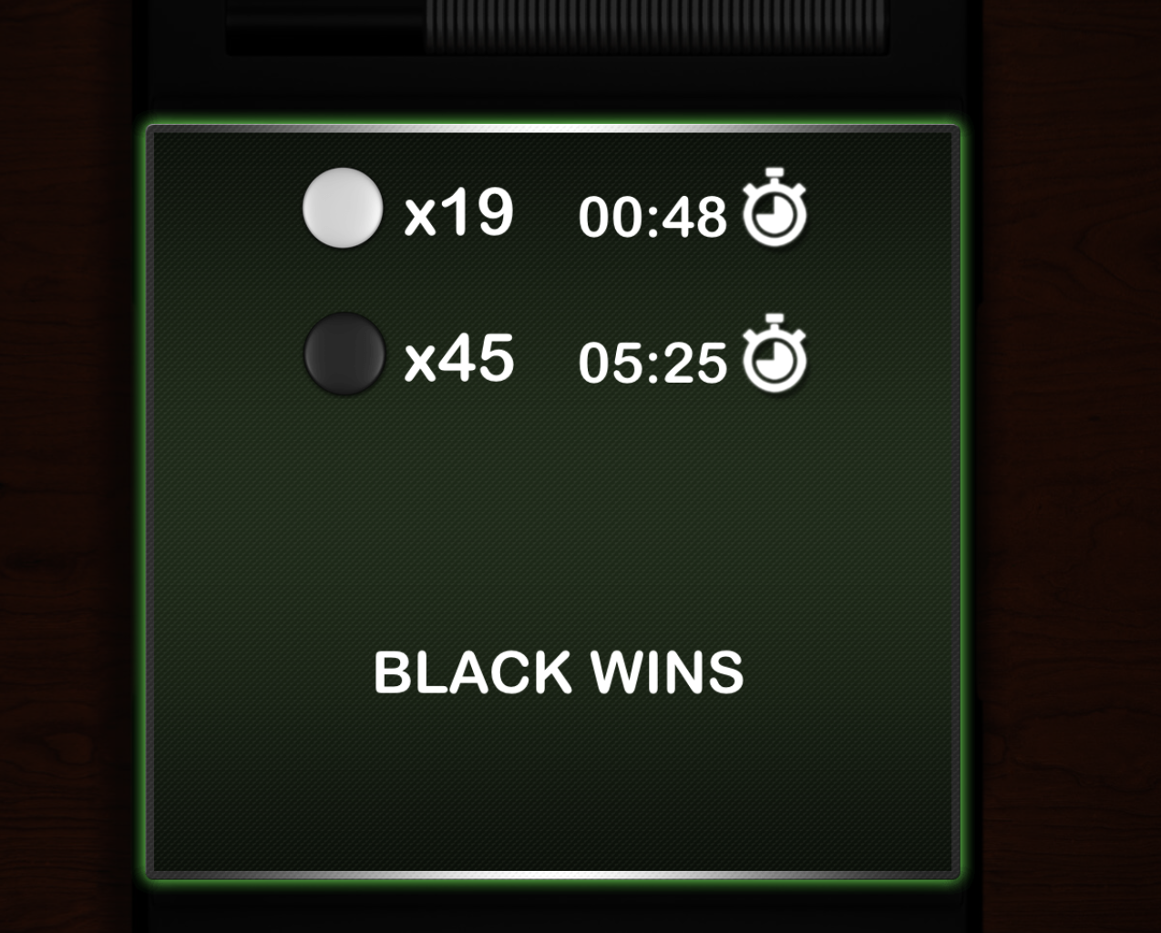

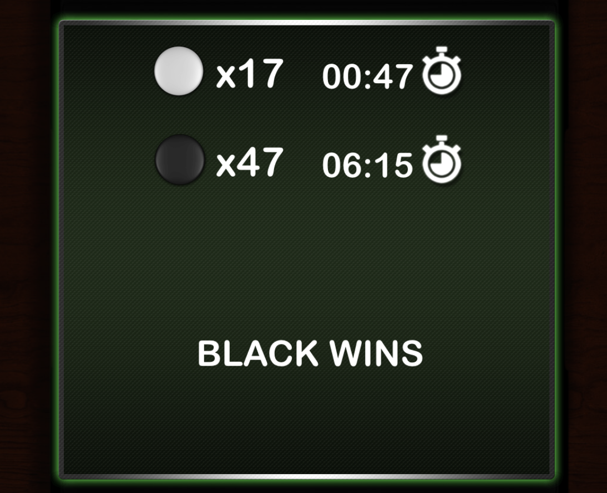

Middle (Two stars):

Probability of winning: 100%

Average number of black discs at winning: 36.6

